Mathematical Expression

🌟 Definition
# Source: AI Source: Provided by: [Data Path: Persons Table -> ID Column: 1, Name_En Column: Motasem Essam] -> From: [ChatGPT] on [5/29/2026]
A mathematical expression is a combination of numbers, variables, and mathematical symbols (such as +, −, ×, ÷) that represents a value or a relationship but does not contain an equality (=) or inequality sign.
It represents something we can calculate or simplify, but it is not a full equation.

🎯 Purpose of a Mathematical Expression
# Source: AI Source: Provided by: [Data Path: Persons Table -> ID Column: 1, Name_En Column: Motasem Essam] -> From: [ChatGPT] on [5/29/2026]
- To represent quantities in a compact form
- To perform calculations
- To describe relationships without solving an equation
- To simplify mathematical operations
- To build equations and formulas

📚 Key Characteristics
# Source: AI Source: Provided by: [Data Path: Persons Table -> ID Column: 1, Name_En Column: Motasem Essam] -> From: [ChatGPT] on [5/29/2026]
A mathematical expression:
- Does not contain =, <, >, ≤, ≥
- Can include numbers, variables, and operators
- Can be simplified or evaluated
- Represents a single value or result
- Is part of larger mathematical structures

🧩 Types of Mathematical Expressions

1. Numerical Expression
# Source: AI Source: Provided by: [Data Path: Persons Table -> ID Column: 1, Name_En Column: Motasem Essam] -> From: [ChatGPT] on [5/29/2026]
Contains only numbers.
Example:
$$5+3×2$$

2. Algebraic Expression
# Source: AI Source: Provided by: [Data Path: Persons Table -> ID Column: 1, Name_En Column: Motasem Essam] -> From: [ChatGPT] on [5/29/2026]
Contains variables and numbers.
Example:
$$x+2y$$

3. Polynomial Expression
# Source: AI Source: Provided by: [Data Path: Persons Table -> ID Column: 1, Name_En Column: Motasem Essam] -> From: [ChatGPT] on [5/29/2026]
Contains powers of variables.
Example:
$$x^{2}+3x+2$$

4. Fractional Expression
# Source: AI Source: Provided by: [Data Path: Persons Table -> ID Column: 1, Name_En Column: Motasem Essam] -> From: [ChatGPT] on [5/29/2026]
Contains fractions.
Example:
$$\frac{x+1}{x-1}$$

✏️ Examples of Mathematical Expressions
# Source: AI Source: Provided by: [Data Path: Persons Table -> ID Column: 1, Name_En Column: Motasem Essam] -> From: [ChatGPT] on [5/29/2026]
- 7 + 4
- x − 5
- 3x + 2
- 2a + 3b − c

🔗 Relationship to Other Concepts
# Source: AI Source: Provided by: [Data Path: Persons Table -> ID Column: 1, Name_En Column: Motasem Essam] -> From: [ChatGPT] on [5/29/2026]
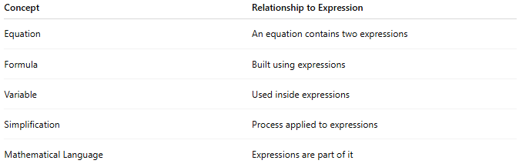
Concept | Relationship to Expression
Equation | An equation contains two expressions
Formula | Built using expressions
Variable | Used inside expressions
Simplification | Process applied to expressions
Mathematical Language | Expressions are part of it

📖 Expression vs Equation vs Formula
# Source: AI Source: Provided by: [Data Path: Persons Table -> ID Column: 1, Name_En Column: Motasem Essam] -> From: [ChatGPT] on [5/29/2026]
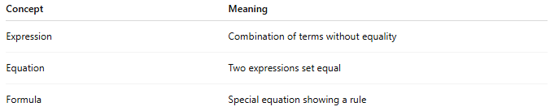
Concept | Meaning
Expression | Combination of terms without equality
Equation | Two expressions set equal
Formula | Special equation showing a rule
Example:
- Expression: $x+3$
- Equation: $x+3=7$
- Formula:
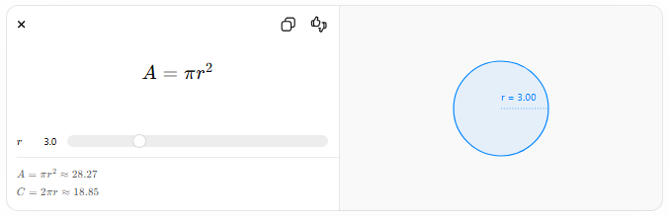
$$A=πr^{2}$$
$$r$$
$$A=πr^{2}≈28.27$$
$$C=2πr≈18.85$$
r = 3.00

🧠 Simple Analogy
# Source: AI Source: Provided by: [Data Path: Persons Table -> ID Column: 1, Name_En Column: Motasem Essam] -> From: [ChatGPT] on [5/29/2026]
A mathematical expression is like a partial calculation or phrase:
- It tells you something about numbers or variables
- But it is not a complete statement until solved or compared

🧭 Summary
# Source: AI Source: Provided by: [Data Path: Persons Table -> ID Column: 1, Name_En Column: Motasem Essam] -> From: [ChatGPT] on [5/29/2026]
A mathematical expression is a combination of numbers, variables, and symbols that represents a value or relationship but does not include an equals sign. It is used for calculation, simplification, and building equations.

